**Easy Adopt SPMP**

**Group 5 (Sean)**

**06/30/21**

**Table Of Contents**

|  |  |
| --- | --- |
| **Topic:** | **Page Number:** |
| **Title Page** | **1** |
| **Table Of Contents** | **2, 3** |
| **Revision Sheet** | **4** |
| **Project Scope** | **5-8** |
| **Introduction** | **9** |
| **Project Overview** | **9** |
| **Project Deliverables** | **9** |
| **Evolution Of SPMP** | **10** |
| **Reference Materials** | **10** |
| **Definitions and Acronyms** | **10** |
| **Part 3: Managerial Process** | **12** |
| **Part 4: Technical Process** | **13** |
| **Part 5: Description of Work Packages** | **14** |
|  |  |
|  |  |
|  |  |
|  |  |
|  |  |

**Table Of Contents**

|  |  |
| --- | --- |
| **Topic:** | **Page Number:** |
|  |  |
|  |  |
|  |  |
|  |  |
|  |  |
|  |  |
|  |  |
|  |  |
|  |  |
|  |  |
|  |  |
|  |  |
|  |  |
|  |  |
|  |  |
|  |  |
|  |  |
|  |  |
|  |  |

**Revision Sheet**

|  |  |  |  |  |  |  |  |
| --- | --- | --- | --- | --- | --- | --- | --- |
| **Week** | **Monday** | **Tuesday** | **Wednesday** | **Thursday** | **Friday** | **Saturday** | **Sunday** |
| **1** |  |  |  |  |  |  |  |
| **2** |  |  |  |  |  |  |  |
| **3** |  |  |  |  |  |  |  |
| **4** |  | **Use Cases** | **Requirements** | **SPMP** | **SPMP** | **SPMP** | **SPMP** |
| **5** | **SPMP** | **Revision** | **Revision** |  |  |  |  |
| **6** |  |  |  |  |  |  | **Gantt chart review/revision/update** |
| **7** | **Design Docs/Test skeleton** |  |  |  |  |  |  |
| **8** |  |  |  |  |  |  |  |
| **9** |  |  |  |  |  |  |  |
| **10** |  |  |  |  |  |  |  |
| **11** |  |  |  |  |  |  |  |
| **12** |  |  |  |  |  |  |  |

**Project Scope**

## **Project Objectives:**

|  |  |
| --- | --- |
| **PROJECT NAME:** | **SUBMISSION DATE:** |
| EasyAdopt | 06/30/2021 |
| * Designated personnel from any animal adoption facility to post information and high-quality images and/videos of domesticated pets available for adoption. * Support rapid updating of any pet’s “adoption” status by facility personnel. * Pet owners or potential owners to view current information on pets needing homes. * Raise funds to support the costs of running facilities for animals awaiting adoption through paid advertising placed on site, raising awareness through social media and donations * Educate pet owners on proper care of pets as well as allow owners to view their pet’s medical records. * Every pet listing should provide certain info. This info can be used as criteria for finding the right pet (filters). Information includes breed, age, gender, behavior, days on website and shelter/location... Etc. * Additionally, each pet listing should require information fields that won’t be able to be used as a filtering criteria, however it is necessary to provide additional, more specific information about the pet. One of the fields can be used for providing the info necessary for educating pet owners on proper care of pets. * When a user enters the website, and prompts to look for a pet, he/she will be asked for their zip code and search radius. * The pet listings can be sorted in various methods * An attached copy of the pets medical record will be available in the pets listing. * Each pet listing will need a “status” field. The field either can be “open” or “in process” if the pet is open for adoption or in the process of potentially being adopted. * Any user of the website can search through pet listings. For a user to begin the adoption process, they will need to have an account with the website. Same thing applies for making donations * Users with accounts will be able to save pet listings | |

**Project Scope**

## **Project Deliverables:**

|  |  |
| --- | --- |
| **DELIVERABLE NO.** | **DESCRIPTION** |
| **1** | Use Cases/Requirements |
| **2** | SPMP |
| **3** | Design Docs |

## **Project Tasks:**

|  |  |  |
| --- | --- | --- |
| **TASK NO.** | **DESCRIPTION** | **FOR DELIVERABLE NO.** |
| **1** | Planning | 1,2,3 |
| **2** | Execution | 2 |
| **3** | Evaluation | 3 |

**Project Scope**

## **Project Constraints:**

|  |  |
| --- | --- |
| **PROJECT START DATE:** | 05/24/21 |
| **LAUNCH / GO-LIVE DATE:** | 07/15/21 |
| **PROJECT END DATE:** | 07/23/21 |
| **LIST ANY HARD DEADLINE(S):** | 06/29/21- SPMP Must Be Done For Revision. |
| **KEY DATES:** | 06/29/21- SPMP Must Be Done For Revision.  06/30/21 - Use Cases/Requirements and SPMP.  7/23/2021 - Final day to resubmit group project deliverables.  8/2/2021 - Group Presentations & Group Project Debrief. |
| **BUDGET LIMITATIONS:** | Less Than 100 Dollars. |
| **QUALITY OR PERFORMANCE CONSTRAINTS:** | Time frame of 6 weeks  Cost of hosting  Benefits |

## **Project Scope**

## **Updated Estimates:**

|  |  |
| --- | --- |
| **Estimate the hours required to complete the project.** | 50 Hours To Complete This Project |

## 

## **SPMP**

## **1. Introduction**

A well-known philanthropist, technology consultant and self-professed “animal lover” has partnered with the Maryland state and local governments, as well as Maryland’s humane societies and vets, to revolutionize the process by which homeless pets are matched with foster families and placed in permanent homes. The tech guru and their team commissioned a study regarding online resources available to Maryland residents looking to adopt or foster pet(s); this team made the following discoveries:

1) There seems to be no centralized website for placing pets throughout the state. Instead many different organizations have their own, often antiquated, websites.

a. Information pertaining to pets available at different locations is not easy to find as most facilities have, at best, unreliable communication between them.

b. There is no single place where any state animal shelter representative can “post” a pet’s info so as to facilitate easy access for potential owners throughout the state.

2) There is insufficient information on a pet’s personality to allow potential adopters to make an informed decision.

This tech guru and their team decided to fund a project with the goal of building a website dedicated to “finding the pet that is perfect for you!”.

## **1.1 Project Overview**

This SPMP document is made for the members of Group 5 to describe the overall management process of the project both technically and financially. This SPMP will help the planning and execution throughout the project’s life cycle, as well as serve as a reference to the deliverables and tasks. The revision sheet and gantt chart will be the focus for the phases and milestones of this project.

## **1.2 Project Deliverables**

The EasyAdopt System will produce:

* Use Cases
* Requirements
* A Software Project Management Plan
* Test Manual
* Source Code

**SPMP**

## **1.3 Evolution of the Software Project Management Plan**

This Software Project Management Plan is under constant control and supervision. Any anticipated and unanticipated changes will be posted and available to all members of group 5 at the end of the week at midnight.

## **1.4 Reference Materials**

* https://www.petfinder.com/

## **1.5 Definitions and Acronyms**

* SPMP - Software Project Management Plan
* QA - Quality Assurance
* UI - User Interface
* UX - User Experience
* HTML - Hypertext Markup Language
* CSS - Cascading Style Sheets
* JS - JavaScript
* MySQL - Structured Query Language
* HTTPS - Hypertext Transfer Protocol Secure
* WBS - Work Breakdown Structure

**SPMP**

## **2.1 Process Model**

The process model used for this project will be an Agile model that will allow us to have an iterative approach which will allow us to focus on the code rather than the design.

## **2.2 Organizational Structure**

**Team Members**

**i.** Sean Hicks

**ii.** Marcus Bryant

**iii.** Lesley Hernandez

**iv.** Matt Clark

**v.** Nicholas Hartnett

## **2.3 Organizational Interfaces**

* GitHub
* Namecheap
* WordPress

## **2.4 Project Responsibilities**

**Team Role Responsibilities**

Team Lead - Sean Hicks

Product Owner - Sean Hicks

Tech Lead - Nicholas Hartnett

Full Stack Developer - Lesley Hernandez

Front End Developer - Lesley Hernandez

Back End Developer - Lesley Hernandez

QA Lead - Matt Clark

QA Engineer - Matt Clark

Tester - Nicholas Hartnett

UI Designer - Marcus Bryant

UX Designer - Marcus Bryant

**SPMP**

## **3.1 Management Objectives and Priorities**

The philosophy adopted by management within this project is created by a strong foundation that revolves around an effective yet easy user friendly website allowing for a maximum number of adoptions. The process is divided into two objectives within this project, which is priorities and requirements. These requirements range anywhere from the user having the ability to search for a pet, to description of a pet, to application process. However, the priorities of management is to ensure fluidity within the website to ensure an easy process when someone is either trying to adopt or donate. In regards to the schedule, we are aiming for 8/2 if not before due to the presentation of this project. The management group is aiming to stay under $100 for this project as a budget.

## **3.2 Assumptions, Dependencies and Constraints**

External events could be proper domain to ensure execution, and proper coding.The only two constraints the project faces is the time frame in which it must be completed, and the budget allocated for this project.

## **3.3 Risk Management**

If the size of the project becomes too large, the management group can consult with the client on restructuring it in order to accommodate needs. If there are multiplying requirements, the management group will have to resize the project in order to specify the previous requirements in order to ensure enough time to finish the project. In order to validate client acceptance, we will try to give the client a prototype about a week and a half before our deadline to make proper changes in order to satisfy the client. A good way to trace risk is to monitor budget, this is a factor that’ll decrease the chances for bankruptcy. The management team can also minimize the need for multiplying requirements by ensuring the cases cover everything.

## **3.4 Risk Management**

The current number of personnel sits at six members. We each specialize in a different language and experiences which allows for multiple perspectives on how to conduct the most effective approach for this project.

## **3.5 Monitoring and Controlling Mechanisms**

We plan on meeting with our client in regards to any reports or issues.

**SPMP**

## **4.1 Methods, Tools, and Techniques**

We will be using Wordpress.org to help incorporate functions into our web app. We plan on using MySQL as a database, and we plan on using HTML/CSS/JS for our frontend. We need to host our web app, and we can use godaddy to register a domain. We may use digital ocean for hosting or name.com

## **4.2 Software Documentation**

ReadMe Documentation will be included in core file repositories, along with thorough documentation of the software development process. Standard coding practices will be implemented as well.

## **4.3 Project Support Functions**

* Plans (at least) the following project support functions.
  + Plan to ensure quality assurance
    - Document tests to make sure edge cases are fulfilled
  + HTTPS
    - Secure site through certification

**SPMP**

**5.1 WBS**

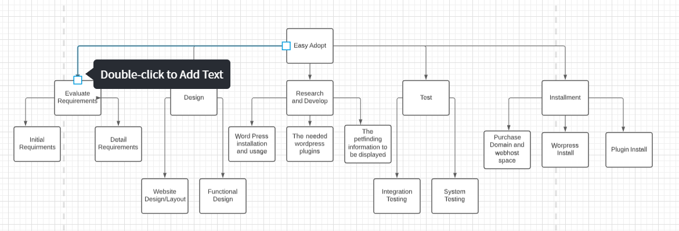

**5.2 Gantt Chart- Also in png form/xlsx form in repo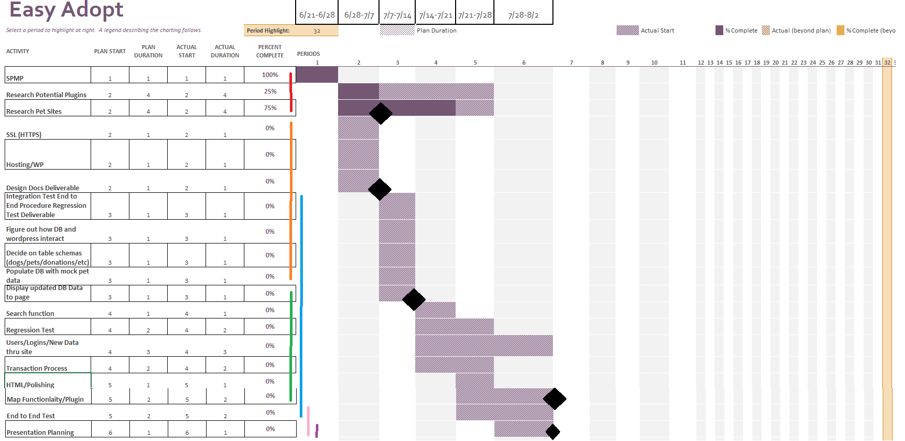 (most recent in repo)**

